***HTML PROJECT REPORT***

***INTRODUCTION: name My is mamta Yadav. And I’m from wazirabad sec 52 (Gurugram). I am pursuing bachelor’s in computer science and technology from St. Andrews institute of technology and management. And from my childhood I’m very attractive and active towards computer and its technology. And very curious to know that how we develop games, apps and how operating system works. I always want to do and explore new thing in my life and think that doing bachelor’s in technology is very interesting that’s why I chose this particular course***

***ACKNOWLEDGEMENT:***

***I WISH TO EXPRESS MY SINCERE GRATITUDE TO MR. GARVIT VERMA, TRAINER FOR PROVIDING ME AN OPPURTUNITY TO DO PROJECT WORK IN "WEBSITE".***

***I SINCERELY THANK THE COMPANY OWNER FORPROVIDING ME THIS OPPURTUNITY.I ALSO WISH TO EXPRESS MY GRATITUDE TO THE OFFICIALS AND OTHER STAFF MEMBERS OF OUR COLLEGE WHO HELP ME DURING THE PERIOD OF MY PROJECT WORK.***

***I ALSO THANK DEAN SIR. AND DIRECTOR SIR OF OUR COLLEGE AND OUR HOD MAM FOR PROVIDING ME THIS OPPURTUNITY TO EMBARK ON MY PROJECT.***

***PROJECT BY: MAMTA YADAV***

***LAB CERTIFICATION***

***THIS IS TO CERTIFY THAT THE PROJECT TITLED “FLIPKART”. THIS PROJECT IS SUBMITTED BY MAMTA YADAV.ST.ANDREWS INSTITUTE OF TECHNOLOGY AND MANAGEMENT IN FULLFILLMENT OF THE REQUIREMENT FOR HTML. THIS PROJECT WAS AN AUTHENTIC WORK DONE BY HIM UNDER MY SUPERVISION AND GUIDANCE.***

***THIS PROJECT HAS NOT BEEN SUBMITTED BY ANY OTHER INSTITUTION FOR THE AWARD OF A DIPLOMA***

***DATE:30/11/2022***

***PROJECT GUIDE: GARVIT VERMA***

***SAITM***

***INDEX***

***INTRODUCTION***

***ACKNOWLEDGEMENT***

***LAB CERTIFICATION***

***SOURCE CODE***

***OUTPUT***

***CONCLUSION***

***SOURCE CODE:***

<!DOCTYPE html>

<html lang="en">

<head>

    <meta charset="UTF-8">

    <meta http-equiv="X-UA-Compatible" content="IE=edge">

    <meta name="viewport" content="width=device-width, initial-scale=1.0">

    <title>e-commerce website</title>

    <style>

        .dropdown{

            position: relative;

            display: inline-block;

        }

        .dropdown-content{

            display: none;

            position: absolute;

            background-color: aqua;

            min-width: 160px;

            box-shadow: 0px 0px 16px 0px rgba(0,0, 0,0,2);

            padding: 12px 16px;

            color: white;

        }

        .dropdown:hover .dropdown-content{

            display: block;

        }

        .zoom:hover{

            transform: scale(1,2);

        }

    input[type="button"]{

        background-color: blue;

    }

    </style>

</head>

<body bgcolor="#f1f3f6">

<div class="dropdown">

    <span></span>

</div>

    <table border="0" width="100%" bgcolor="blue">

        <tr>

            <td align="right"><img src="Flipkart logo2.jpg" height="40px"></td>

            <td><input type="text" placeholder="search for products, brands and more" style="width:550px;height: 35px;" >

                <input type="button" value="search" style="width:125px ; height:35px ;"

            </td>

            <th><font color="white">login&signup</font></th>

            <th><font color="white">more</font></th>

            <th><img src="cart logo.jpg" height="40px"></th>

        </tr>

    </table>

    <table border="0" width="100%" bgcolor="white" height="9%">

        <tr>

            <th width="12.8">

            <div class="dropdown">

           <span>

            ELECTRONICS

           </span>

           <div class="dropdown-content">

            <p>LAPTOPS</p>

            <p>MOBILE</p>

            <p>CHARGER</p>

            <p>SPEAKER</p>

           </div></th>

<th width="12.8">

    <div class="dropdown">

       <span>TV & APPLIANCES</span>

       <div class="dropdown-content">

        <p>LED</p>

       <p>FRIDGE</p>

       <p>COOLER</p>

       <p>AC</p>

       <p>WASHING MACHINE</p>

       </div></th>

       <th width="12.8">

        <div class="dropdown">

       <span>MEN</span>

       <div class="dropdown-content">

        <p>JEANS</p>

        <p>SPORTS</p>

        <p>SHIRT</p>

        <p>T-SHIRT</p>

       </div></th>

       <th width="12.8">

        <div class="dropdown">

       <span>WOMEN</span>

       <div class="dropdown-content">

        <p>JEANS</p>

        <p>SPORTS</p>

        <p>TOPS</p>

        <p>LEHENGA</p>

       </div></th>

       <th width="12.8">

<div class="dropdown">

         <span>BABY & KIDS</span>

         <div class="dropdown-content">

            <p>WINTER WEAR</p>

            <p>MOSTURISER</p>

            <p>OIL</p>

            <b>CREAM</b>

            <P> CLOTHING</P>

            <th width="12.5%">

                <div class="dropdown">

                <span>HOME & FURNITURE</span>

                <div class="dropdown-content">

<p>BED</p>

<p>ALMIRAH</p>

<p>CHAIR</p>

<p>HOME DECORATION</p>

                </div>

            </th>

            <th width="12.5%">

                <div class="dropdown">

                <span>SPORTS, BOOKS , MORE...</span>

                <div class="dropdown-content">

<p>TENNIS</p>

<p>BADMINTON</p>

<p>INDIAN HISTORY BOOK</p>

<p>QNA BANK</p>

                </div>

            </th>

            <th width="12.5%">

                <div class="dropdown">

                <span>OFFERS...</span>

                <div class="dropdown-content">

<p>GET 20% OFF/p>

<p>BUY ONE GET ONE FREE</p>

<p>SOECIAL DISCOUNT FOR NEW USER</p>

<p>BUY 1 GET 2  FREE</p>

                </div>

            </th>

        </tr>

    </table>

    <img src="banner1.jpg" width="100%">

    <br>

    <table border="0" width="100%" bgcolor="white">

        <tr>

            <td colspan="0"><h2>school bags</h2></td>

        </tr>

        <tr>

            <th><img src="bag1.jpg" width="100%" class="zoom"></th>

            <th><img src="bag2.jpg" width="100%" class="zoom"></th>

            <th><img src="bag3.jpg" width="100%" class="zoom"></th>

            <th><img src="bag4.jpg" width="100%" class="zoom"></th>

            <th><img src="bag5.jpg" width="100%" class="zoom"></th>

        </tr>

        <tr>

            <th><font color="green">price: 599/-</font></th>

            <th><font color="green">price: 799/-</font></th>

            <th><font color="green">price: 699/-</font></th>

            <th><font color="green">price: 499/-</font></th>

            <th><font color="green">price: 999/-</font></th>

        </tr>

        <th><input type="button" value="show details"></th>

        <th><input type="button" value="show details"></th>

        <th><input type="button" value="show details"></th>

        <th><input type="button" value="show details"></th>

        <th><input type="button" value="show details"></th>

    </table>

    <table border="0" width="100%" bgcolor="white">

        <tr>

            <td colspan="0"><h2>party wear dresses</h2></td>

        </tr>

        <tr>

            <th><img src="dress1.jpg" width="100%" class="zoom"></th>

            <th><img src="dress2.jpg" width="100%" class="zoom"></th>

            <th><img src="dress3.jpg" width="100%" class="zoom"></th>

            <th><img src="dress4.jpg" width="100%" class="zoom"></th>

            <th><img src="dress5.jpg" width="100%" class="zoom"></th>

        </tr>

        <tr>

            <th><font color="green">price: 599/-</font></th>

            <th><font color="green">price: 799/-</font></th>

            <th><font color="green">price: 699/-</font></th>

            <th><font color="green">price: 499/-</font></th>

            <th><font color="green">price: 999/-</font></th>

        </tr>

        <th><input type="button" value="show details"></th>

        <th><input type="button" value="show details"></th>

        <th><input type="button" value="show details"></th>

        <th><input type="button" value="show details"></th>

        <th><input type="button" value="show details"></th>

    </table>

    <table border="0" width="100%" bgcolor="white">

        <tr>

            <td colspan="5"><h2>shoes</h2></td>

        </tr>

        <tr>

            <th><img src="shoes1.jpg" width="100%"class="zoom"></th>

            <th><img src="shoes2.jpg" width="100%"class="zoom"></th>

            <th><img src="shoes3.jpg" width="100%"class="zoom"></th>

            <th><img src="shoes4.jpg" width="100%"class="zoom"></th>

            <th><img src="shoes5.jpg" width="100%"class="zoom"></th>

        </tr>

        <tr>

            <th><font color="green">price: 599/-</font></th>

            <th><font color="green">price: 799/-</font></th>

            <th><font color="green">price: 699/-</font></th>

            <th><font color="green">price: 499/-</font></th>

            <th><font color="green">price: 999/-</font></th>

        </tr>

        <th><input type="button" value="show details"></th>

        <th><input type="button" value="show details"></th>

        <th><input type="button" value="show details"></th>

        <th><input type="button" value="show details"></th>

        <th><input type="button" value="show details"></th>

    </table>

    <table border="0" width="100%" bgcolor="white">

        <tr>

            <td colspan="5"><h2>mobile</h2></td>

        </tr>

        <tr>

            <th><img src="ph1.jpg" width="100%"class="zoom"></th>

            <th><img src="ph2.jpg" width="100%"class="zoom"></th>

            <th><img src="ph3.jpg" width="100%"class="zoom"></th>

            <th><img src="ph4.jpg" width="100%"class="zoom"></th>

            <th><img src="ph5.jpg" width="100%"class="zoom"></th>

        </tr>

        <tr>

            <th><font color="green">price: 55,599/-</font></th>

            <th><font color="green">price: 65,799/-</font></th>

            <th><font color="green">price:75,699/-</font></th>

            <th><font color="green">price:17,499/-</font></th>

            <th><font color="green">price: 18,999/-</font></th>

        </tr>

        <th><input type="button" value="show details"></th>

        <th><input type="button" value="show details" ></th>

        <th><input type="button" value="show details"></th>

        <th><input type="button" value="show details"></th>

        <th><input type="button" value="show details"></th>

    </table>

    <table border="0" width="100%" bgcolor="white">

        <tr.,mbvc>

            <td colspan="5"><h2>

                HOME APPLIANCES

            </h2></td>

        </tr>

        <tr>

            <th><img src="wash1.jpg" width="100%"class="zoom"></th>

            <th><img src="wash2.jpg" width="100%"class="zoom"></th>

            <th><img src="fridge3.jpg" width="100%"class="zoom"></th>

            <th><img src="FRIDGE6.JPG" width="100%"class="zoom"></th>

            <th><img src="oven5.jpg" width="100%"class="zoom"></th>

        </tr>

        <tr>

            <th><font color="green">price: 599/-</font></th>

            <th><font color="green">price: 799/-</font></th>

            <th><font color="green">price: 699/-</font></th>

            <th><font color="green">price: 499/-</font></th>

            <th><font color="green">price: 999/-</font></th>

        </tr>

        <th><input type="button" value="show details"></th>

        <th><input type="button" value="show details"></th>

        <th><input type="button" value="show details"></th>

        <th><input type="button" value="show details"></th>

        <th><input type="button" value="show details"></th>

        </tr>

    </table>

    <table border="0" width="100%" bgcolor="white">

        <tr>

            <td colspan="5"><h2>books</h2></td>

        </tr>

        <tr>

            <th><img src="book1.jpg" width="100%"class="zoom"></th>

            <th><img src="book2.jpg" width="100%"class="zoom"></th>

            <th><img src="book3.jpg" width="100%"class="zoom"></th>

            <th><img src="book4.jpg" width="100%"class="zoom"></th>

            <th><img src="book5.jpg" width="100%"class="zoom"></th>

        </tr>

        <tr>

            <th><font color="green">price: 599/-</font></th>

            <th><font color="green">price: 799/-</font></th>

            <th><font color="green">price: 699/-</font></th>

            <th><font color="green">price: 499/-</font></th>

            <th><font color="green">price: 999/-</font></th>

        </tr>

        <th><input type="button" value="show details"></th>

        <th><input type="button" value="show details"></th>

        <th><input type="button" value="show details"></th>

        <th><input type="button" value="show details"></th>

        <th><input type="button" value="show details"></th>

    </table>

    <table border="3" width="100%">

        <td>

            <td bgcolor="black"><font color="white"> quicks links</td></font>

            </td>

            <td bgcolor="black"> <font color="white ">FOLLOW US</td></font>

            <td bgcolor="black"><font color="white">SEARCH</td></font>

            <td bgcolor="black"><font color="white">QUICK LINKS</td></font>

            <td bgcolor="black"><font color="white">CONTACT US</td></font>

        </td>

    </table>

</body>

</html>

***OUTPUT:***

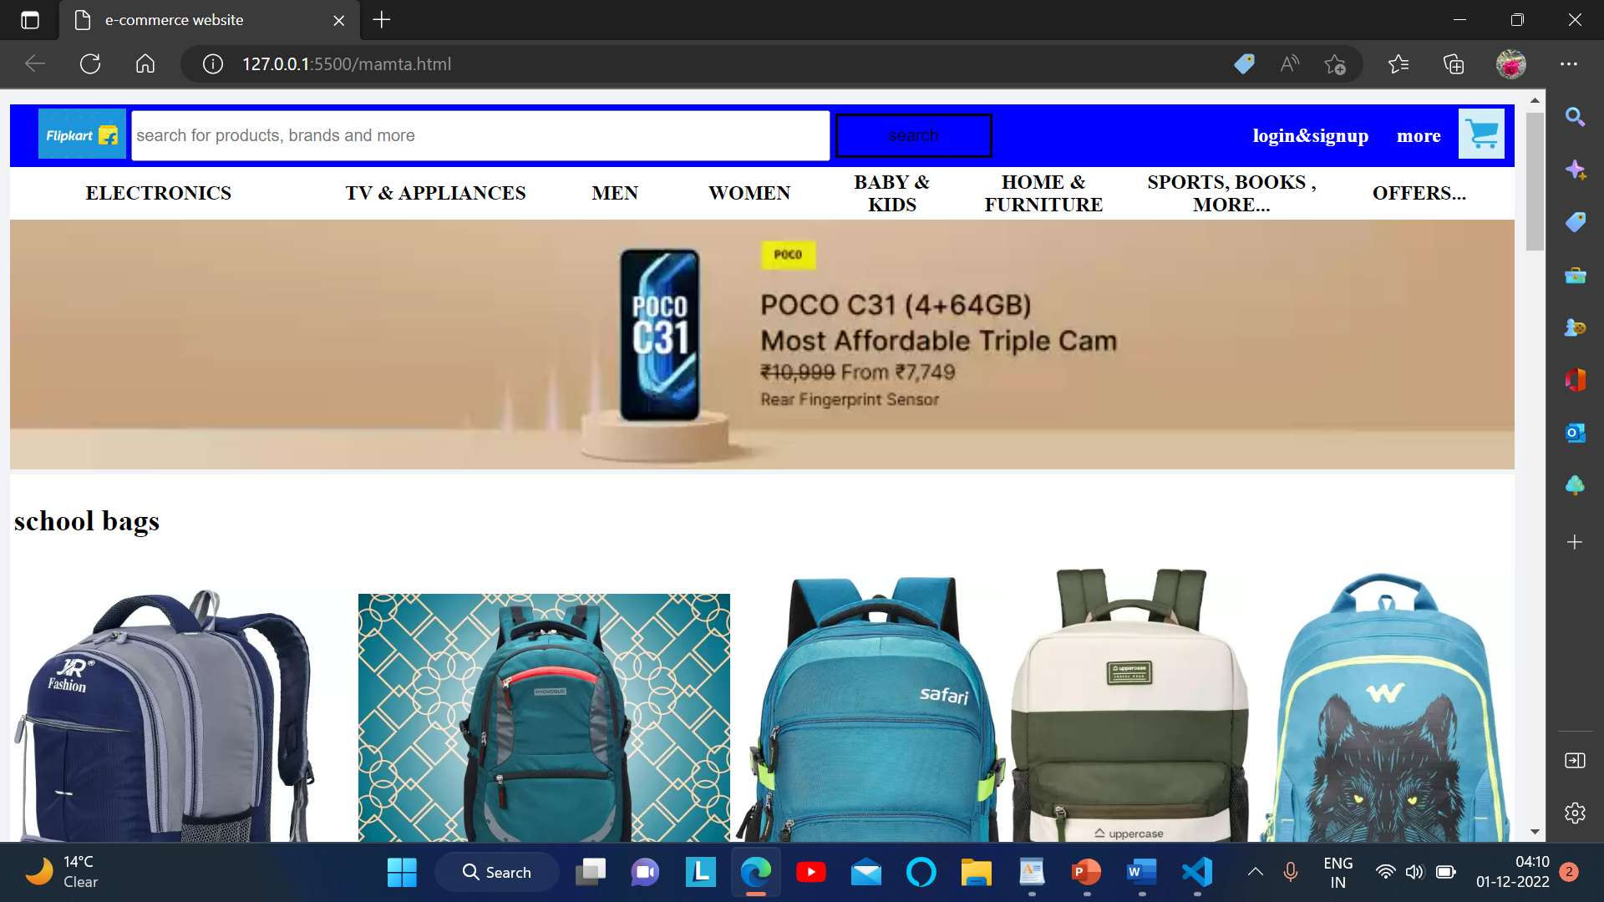

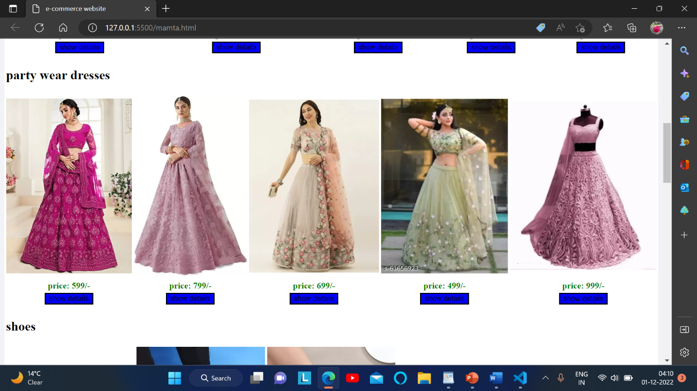

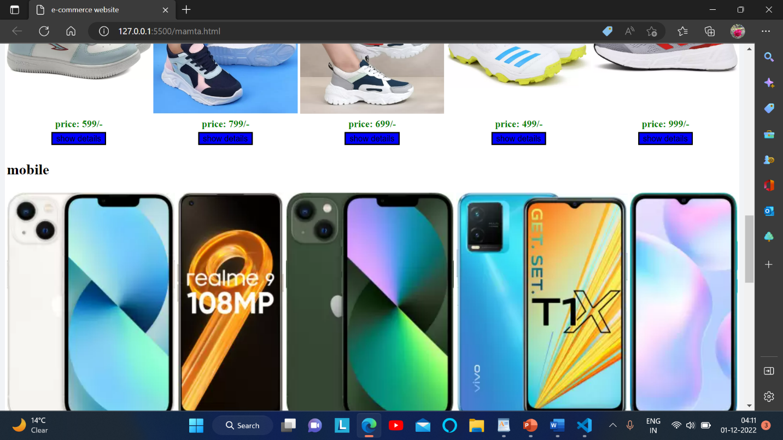

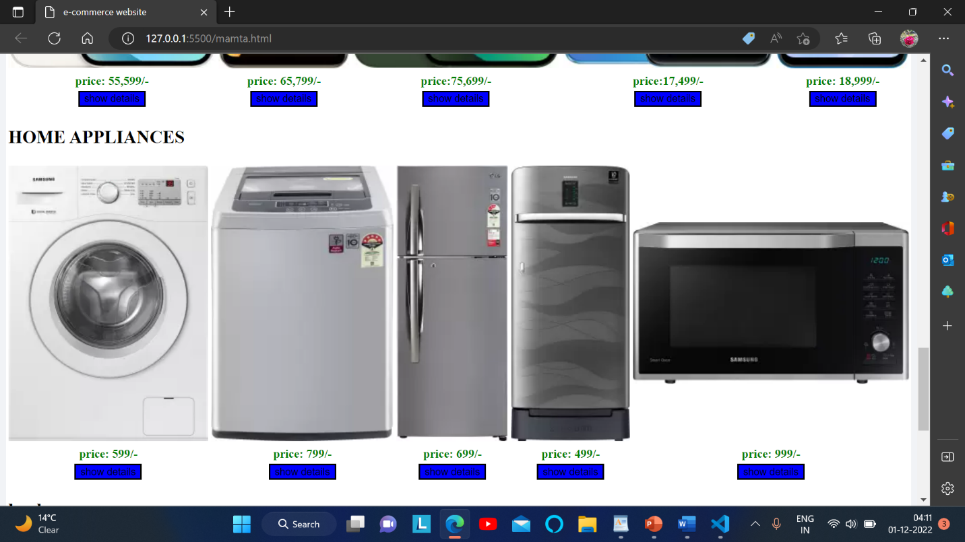

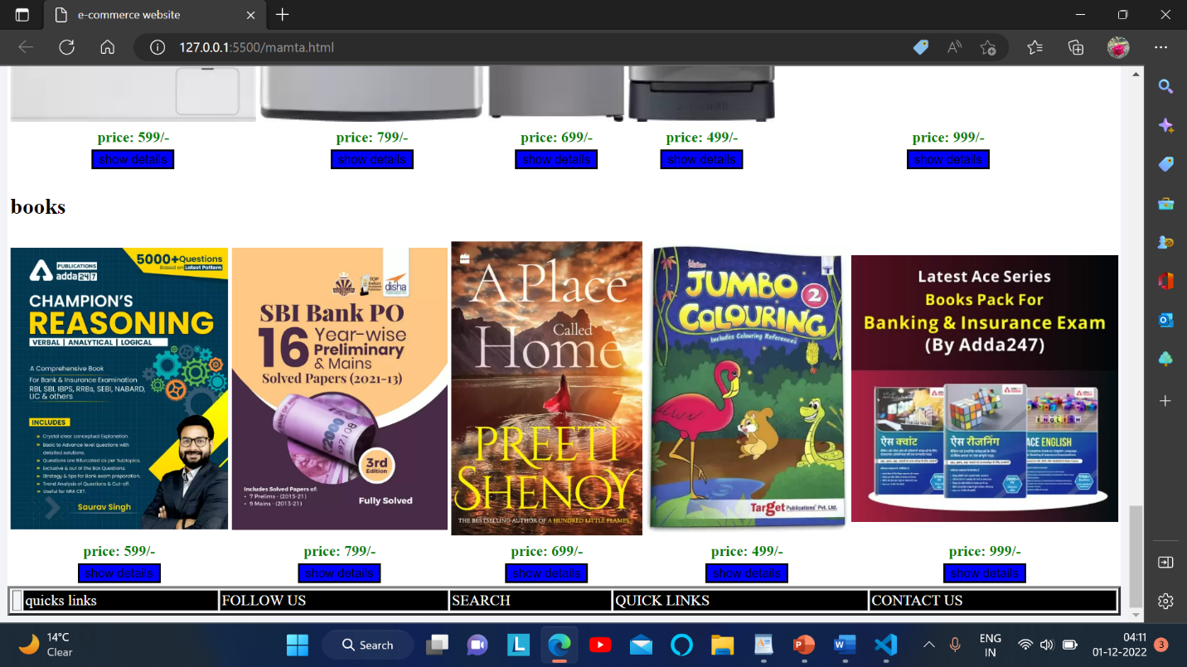

***CONCLUSION: I MADE A USEABLE WEBSITE WHICH IS FLIPKART.***

***WHICH IS NOT ONLY GOOD FOR ONE OR TWP PERSONDS BUT IT HELPS MORE THEN A BILLION PEOPLE AT A SAME TIME.***

***WE CAN EASILY ACCESS AND LOGIN IN THAT WEBSITE AND EASILY ORDER WHATEVER WE NEET TO AND ITS HELPS A LOT PEOPLE BY ITS WORK BECAUSE IN TODAT LIFE EVERYONE IS SO BUSY THAT THEY DON’T EVEN HAVE A TIME TO BUY THINGS FOR THEM SO ITS JEKLPS THEM TO DO WORK MORE EASILY.***